Date:

Job Title | :
Department | :
Location | :
Reporting To | :
Direct Reports | :
Functional Relationships with | : | Internal  External
Our Purpose, Values and Standards
At the heart of Waitematā DHB is our promise of ‘best care for everyone’. This promise statement is the articulation of our three-fold purpose to:
- promote wellness,
- prevent, cure and ameliorate ill health and
- relieve the suffering of those entrusted to our care.
At the heart of our values is the need for all of us to reflect on the intrinsic dignity of every single person that enters our care. It is a privilege to be able to care for patients, whānau and our community, a privilege that is sometimes overlooked in our day to day work.
Our standards and behaviours serve as a reminder to us all about how we are with our patients and with each other.
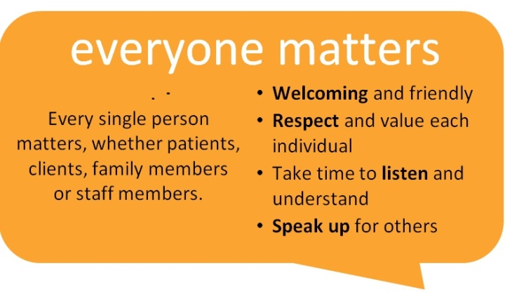
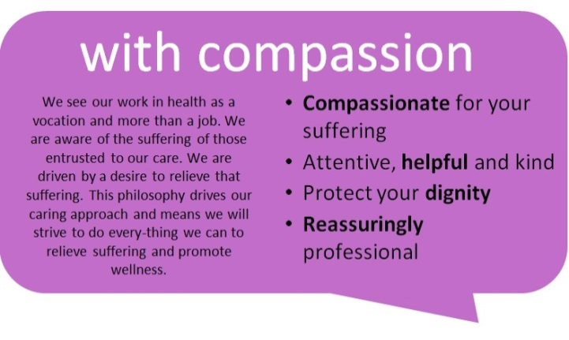
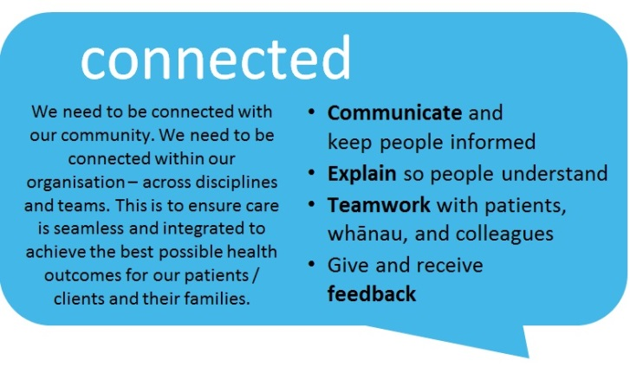
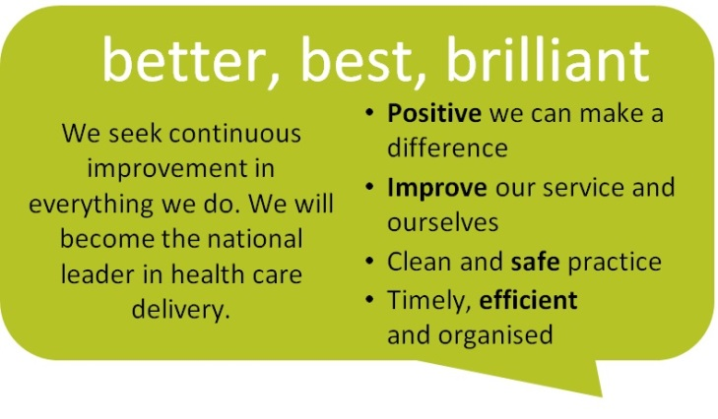

Purpose of the role | :

KEY TASKS | EXPECTED OUTCOMES
 | .
Responsibility for privacy | Ensure that personal and health information (patient, staff, corporate) is managed in accordance with Waitematā DHB’s privacy policies and relevant privacy laws and regulations, and that privacy breaches are investigated, reported and corrective action implemented in line with Waitematā DHB policy.
Statutory & Treaty of Waitangi obligations | Ensures that Waitematā DHB  - meets all statutory regulatory and contractual obligations, including financial reporting, compliance with occupational health and safety, and employment and privacy legislation.  - operates in ways that reflect the intent of the Treaty of Waitangi and achieves related objectives determined by Waitematā DHB.
To recognise individual responsibility for workplace Health & Safety under the Health and Safety at Work Act 2015 | NOTE: DELETE THE SECTION BELOW IF THE ROLE IS NOT A MANAGERIAL ROLE  Contribute to a safe and healthy workplace at WDHB by:  All Level Managers  - Following, implementing, monitoring & ensuring compliance with all H&S policies & processes  - Timely escalation of issues to Risk Register as required  - Planning, organising & managing H&S activities directed at preventing harm & promoting wellbeing in the workplace  - Ensuring a safe working environment & safe working practices through the Safe Way of Working H&S system  - Early and accurate reporting of incidents at work and raising issues of concern when identified.  Contribute to a safe and healthy workplace at Waitematā DHB by:  All Employees  - Following & complying with H&S policies & processes & applying them to their own work activities, including using/wearing Personal Protective Equipment as required.  - Participating in activities directed at preventing harm & promoting well-being in the workplace  - Identifying, reporting & self-managing hazards where appropriate  - Early and accurate reporting of incidents at work and raising issues of concern when identified.

PERSON SPECIFICATION
POSITION TITLE:

 | Minimum | Preferred
Qualification

Experience

Skills/Knowledge/Behaviour

